**PyCitySchools Analysis**

**District Summary:**

* There are a total of 15 schools within the dataset with 39170 total students.
* 74.98% of students passed math & 85.80% of students passed reading. While 65.17% of students passed BOTH Math & Reading (Passing criteria >=70).



**School Summary:**

* Budgets of schools vary from just over $3.1m to just under $250k with Baily High School being the largest budget & Holden High School being the smallest budget.

**Highest & Lowest Performing Schools (by % Overall Passing):**

* Cabrera High School is the highest performing School by % Overall Passing at 91.34%.
* Rodriguez High School is the lowest performing School by % Overall Passing at 52.99%.

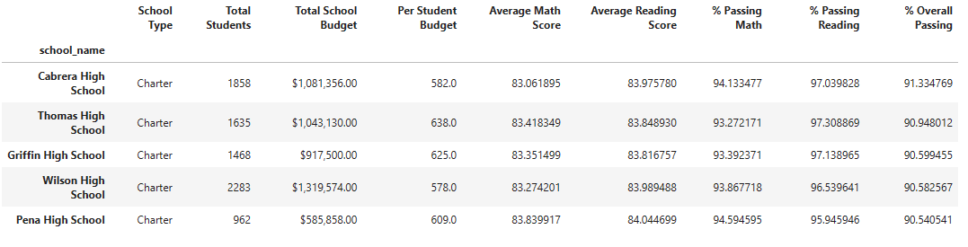

**Math & Reading Scores by Grade:**

* It is difficult to draw any conclusions from Math or Reading scores by grade.

**Math Scores Reading Scores**

**Scores by School Spending:**

* Surprisingly the less money spent per student results the better math, reading, & overall passing rates among students.

**Scores by School Size:**

* There is no noticeable difference between small & medium sized scores; however, large schools are performing drastically work when it comes to passing Math, Reading, & overall passing both.

**Scores by School Type:**

* Charter Schools perform at a much stronger rate than District Schools. Over 90% of students are passing at Charter Schools, meanwhile just over half for District Schools.

